|  |
| --- |
| Photo displaying partial image of two pie charts on a canvas-textured page |
| Analytical SQl  Case Study |
| |  |  |  | | --- | --- | --- | | Farrah Hatem Muhammed | 3/15/24 | Analytical SQL | |

**Analytical SQL Case Study**

**First Question:**

1. **Top 10 Bestselling Products:**

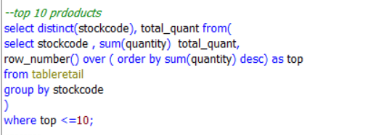

The output:

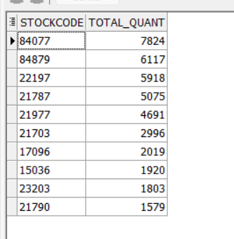

* **Explanation**: This query lists the top 10 products by total quantity sold.
* **Meaning:** It helps the business identify its most popular products and ensure they are adequately stocked and promoted.

1. **Top 5% of Customers:**

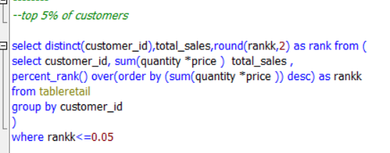

The output:

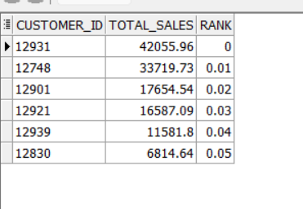

* **Explanation:** This query identifies the top 5% of customers based on their total spending.
* **Meaning:** It helps the business focus on its most valuable customers and tailor special offers or loyalty programs to retain their loyalty.

1. **Customer Purchase Behavior Analysis:**

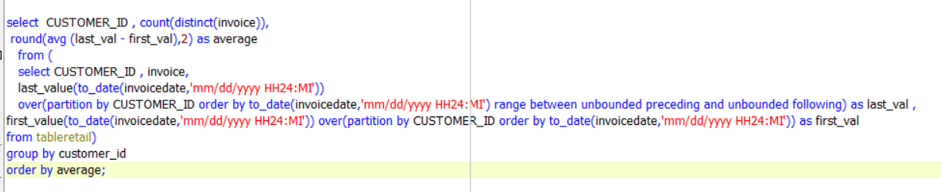

The Output:

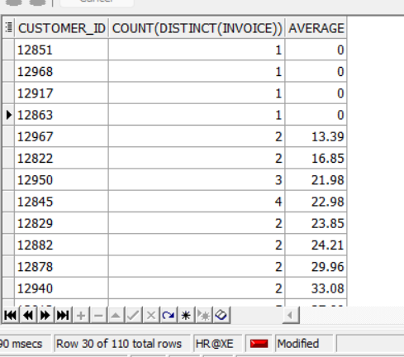

* **Explanation:** This query helps understand how many times each customer made a purchase and calculates the average time between their first and last purchase.
* **Meaning:** By knowing how often customers buy and how long they remain active, the business can tailor marketing and engagement strategies to keep them coming back.

1. **Average Purchase Value per Product:**

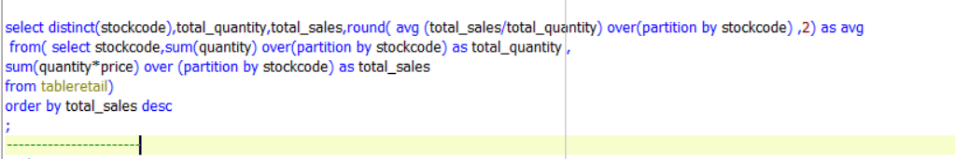

The output:

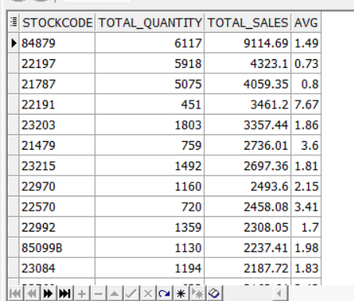

* **Explanation:** This query finds the average amount customers spend on each product, helping identify high-value items.
* **Meaning:** It helps the business focus on products that bring in more revenue per sale and adjust pricing or promotions accordingly.

1. **Customer Lifetime Value :**

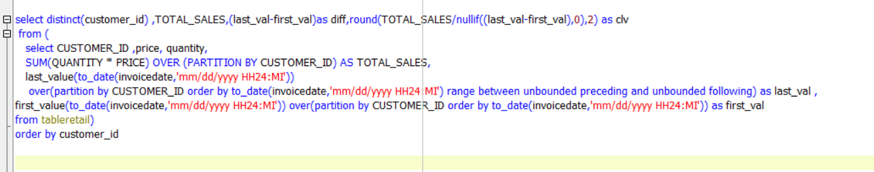

The Output:

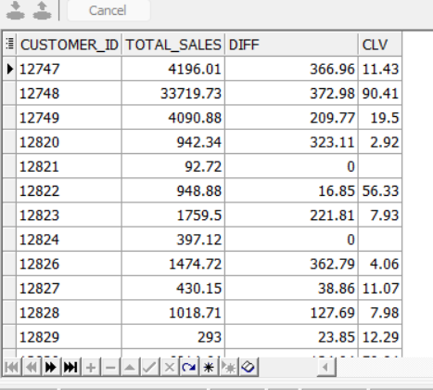

* **Explanation:** This query calculates the expected revenue from each customer over their entire relationship with the business.
* **Meaning:** It helps the business understand the long-term value of its customers and prioritize efforts to retain the most valuable ones.

1. **Customer Count per Month:**

The output:

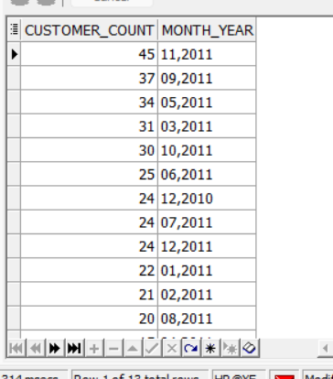

* **Explanation:** This query counts the number of unique customers for each month.
* **Meaning:** It helps the business understand seasonal trends in customer activity and plan marketing campaigns accordingly.

1. **Product Sales Quantity per Month:**

The output:

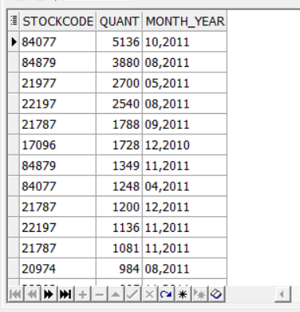

* **Explanation**: This query shows the quantity of each product sold for each month.
* **Meaning**: It helps the business analyze product popularity and adjust inventory levels or promotions based on demand trends.

1. **Monthly Sales Growth Rate:**

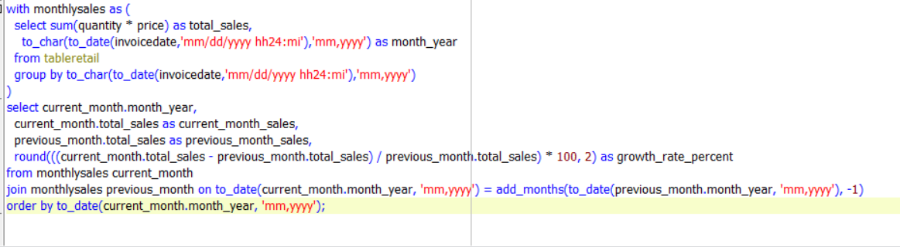

The Output:

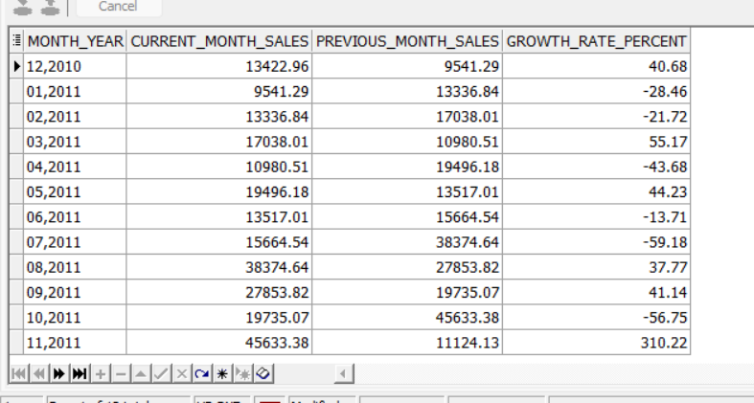

* **Explanation:** This query calculates how much sales have grown or declined from one month to the next.
* **Meaning:** By tracking these changes, the business gains insights into sales trends, enabling adjustments in inventory management and promotional strategies to optimize revenue generation during periods of growth and mitigate declines.

1. **Customer Acquisition Rate:**

The Output:

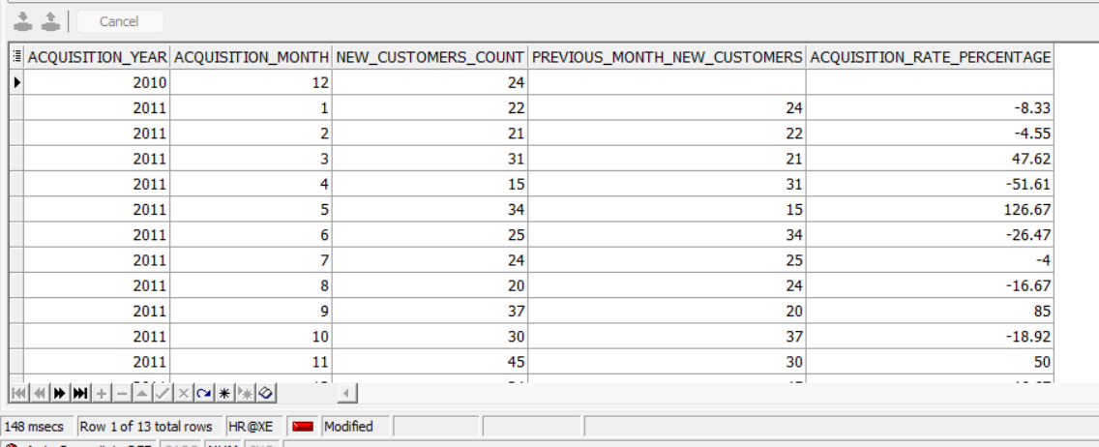

**Explanation:** This query measures how quickly the business is gaining new customers over a specific period.

**Meaning**: By monitoring customer acquisition, the business can evaluate the success of its marketing campaigns and refine its strategies to attract a larger customer base. This helps in optimizing resources and investments to drive sustainable growth.

**Second Question:**

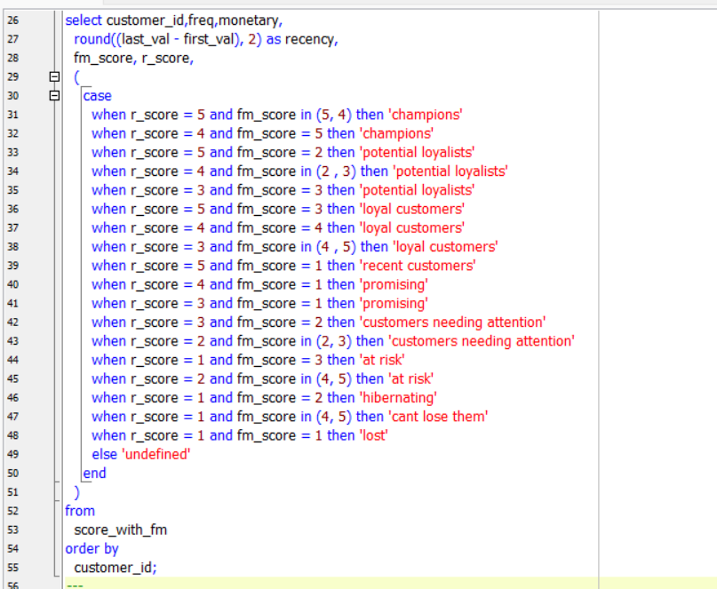

The Output:

**Explanation:** This query segments customers based on their transaction frequency, monetary value, and recency of purchase.

**Meaning:** By analyzing customer behavior, such as how often they buy, how much they spend, and when they last made a purchase, the business can categorize customers into different segments. Each segment represents a different level of engagement and loyalty. This helps tailor marketing strategies and customer service efforts to better meet the needs of each segment, ultimately maximizing customer satisfaction and profitability.

**Third Question:**

**A-**

The Output:

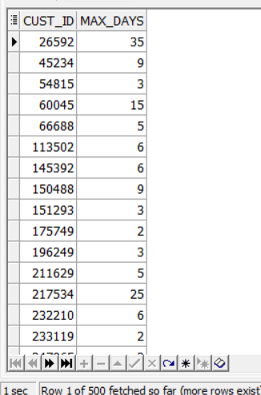

* This tells the longest streak of consecutive days a customer made purchases. It's important because it shows how regularly customers buy from the business.
* It shows how loyal and engaged customers are with our brand.
* Identifies customers at risk of leaving, allowing us to intervene and retain them.

**B-**

The output:

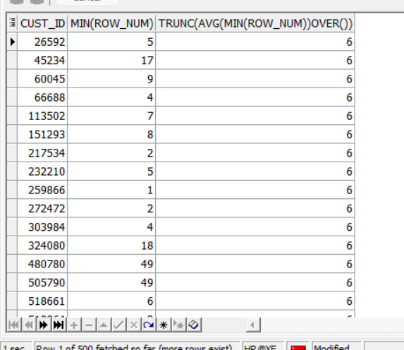

* It helps identify customers who have spent at least $250 and calculates the average ranking among them. This information provides insights into the typical spending habits of these customers.